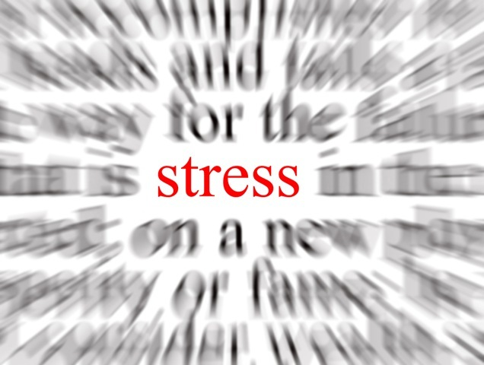  Stress  Sociology 2600-002 | Sheena Christison  Marriage & Family

Stress
By failing to prepare, you are preparing to fail.
– Benjamin Franklin

Introduction
Stress is an attribute that most have experienced throughout the course of life. Commonly used to express feelings of overwhelm, pressure or challenge. The human body is built in such a way that when faced with a challenge or a threat, the body activates resources to protect itself; ultimately, avoiding the physical and psychological effects that stress has on the body and mind. Learning how to identify the triggers for stress can help with avoiding them or how to implement ways to accept them, in such a way that the effects of them are easier to bare.
Stress has always been a substantial part of my own life beginning from the early moments of childhood to the present time. Regardless of the pleas from my immediate family, I could not rest the “business” that engulfed my brain, even my body’s own signals through stomach pains; I continued to allow stress into my life.

List of Stressors
Between the many stressors throughout my life, in particular this past year I begin to feel overwhelmed by having to identify each one. I found the self-assessment within our textbook to be beneficial in regards to organizing and identifying with my current stressors, all of which can stem from positive and negative life events.

Health Stress
- Weight/Exercise
A consistent stress currently as well as throughout my life has always been from my body weight and the need/want to exercise. The need in always thriving to be ten pounds lighter and the want in exerting myself just one more hour is a constant battle.
I would categorize weight/exercise as a form of distress. I have a feeling of unpleasantness, anxiety all of which ultimately decreases my performance.
- Mental Health
Growing up allows a person to recognize their own attributes. One of which is my need to be in control as well as to have and maintain control over my life as well as everything that surrounds it; doctors will call this OCD and anxiety, I call it being a regulator.
Being an obsessive, compulsive, and an anxiety-ridden person can cause breakdowns, depression, and nervousness all of which stem from stressor overload.
- Major Change in Sleeping Habits
It appears to me that since I became a mother nearly five years ago I (like most parents) have become sleep deprived. Either from the disruption that is a direct result of caring and tending to the needs of children or the nights of which I stay awake in order to gain personal serenity. College has also been a result of lack in sleep due to evening classes and late night studying.
Lack of sleep is correctly emphasized as a distress, for there is no reason of positive outcomes stemming from it.
Home & Family Stress
- Mother/Wife
Being a mother bares responsibly and structure that, at times can become overwhelming and stressful, along with the obligations in contributing and maintaining a successful marriage.
I would consider the stress of being a mother and wife as a eustressor. Although at times it is challenging the excitement, joy and happiness is outweighing.
- Major Change in Health of Family Member
Over the course of two and a half years, my husband has undergone three knee and one wrist surgery, all of which were work related.
My husband’s health has caused a stressor overload for me and the family (not to mention him as well). Moreover, the fact that not just one surgery but also a series of them in a small amount of time has disrupted the ‘flow’ for which our family is used to. Furthermore, distress can also be an example as well.
Personal & Social Stress
- College: beginning, ending, and changing of
Recently I have made a major decision concerning my immediate as well as my distant future, which has exceeded a personal achievement. Graduating from one school and continuing onto another allows for a great deal of pride and self-worth. Nevertheless, stress is a factor to any major change in life.
I am confident to consider the personal & social stress currently in my life as a distress and eustress. Although challenging, time consuming, and at times overwhelming, the results show positive attributes.
Financial Stress
- Purchases
Money has such a colossal meaning for such a simple word. Whether you have more than enough or on the contrary, you have the bare minimum it takes to survive; surely both cause stress. It has become apparent to me that whenever my husband and I decide upon making a purchase either large or small I react instantaneously with ‘buyer’s remorse’. Our most recent purchase was of new windows for our home.
Although the major purchases throughout life are distressful, that is all that they are; mere moments in time that are traversable.
(Self-Assessment: Major Life Events & Stress Score: 344/500)

Defense Mechanisms
Throughout life, I have used many mechanisms for denying, excusing, disguising and changing my behaviors in order to avoid anxiety and frustration.
I have repressed memories from my childhood in order to redefine myself; however, I have learned that confronting memories is more beneficial in coping. I have used denial towards a person, memory or happening; in turn, learning that it only delays the inevitable. I have rationalized behaviors for others and myself in hopes to make true reasoning go unnoticed. I have often displaced feelings in order to avoid my own faults and frustrations towards something or someone as a substitute; additionally projecting unacceptable impulses towards others. Often people use the reaction formation mechanism in order to persuade those around us that we are feeling opposite of what we present. Correspondingly, to wear a mask so that others are unable to see our cries, our lies, our tears and sighs.

Strategies for Living
- Reduce the Stressors
Take charge of your thoughts, emotions, schedule, and the way you deal with problems. The simple realization in identifying your stressors shows you are in control of your life; this is the foundation of stress management.
- Manage your Emotional Response
Learning how to increase your awareness and evaluate your own emotions will help in identifying your responses towards a person or individual. Becoming more mindful of your thoughts and challenging them will help in not only taking them at face value, but simply as a thought you are having for the simple reason that you are human.
- Develop a Support System
Connecting with others who enhance your life will help shield you from the negative effects of stress. Being in the presence of positive people will help enhance your own outlook on life.

- Take Care of your Body
Set aside time for leisure activities that bring happiness into your life. Physical activity coupled with being wee-nourished is key in reducing and coping with the effects of stress.
- Develop Relation Techniques
I often say “Always in a hurry to go nowhere fast”, to emphasize the pace in which people (myself included), move through life. Taking the time to stop and allow yourself to relax will put you in a better place to handle when life’s inevitable stressors arise.
Examples:
- Go for a walk
- Call a friend
- Write in a journal
- Take a bath
- Embrace nature
- Play with pet
- Work in your garden
- Read a book
- Listen to music
- Watch a funny show/movie

Conclusion
A point often overlooked is that positive and negative life events will in fact cause stress. However, it is in the ability to identify and manage stress is where you can find liberation.

