2012
Sheena Christison
HLTH 1050
12/10/2012
Drugs, Behavior and Modern Society
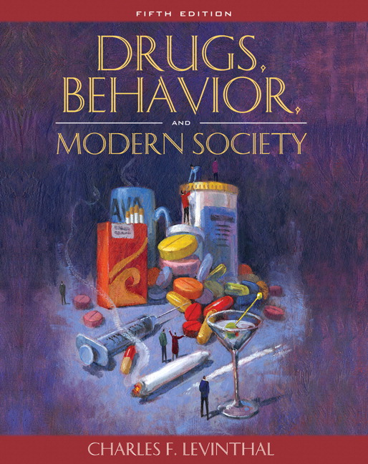
(Levinthal, 2007)
My interest towards Life, Society, & Drugs immediately began with the course description; like most people, I have witnessed drugs, addiction, and recovery. Personally, I have never had to go through this; however, with addiction in my family I am aware of the potential risks that make be more susceptible to addictive behavior. Unlike my older sibling who does suffer from addiction, my life’s direction leads me to the mystery behind the science. Is my interest in psychology an underlying interest to the answers of my life’s challenges?
Looking back to day one I recollect learning the history of drugs; presented all in one class allowed for a solid foundation for the semester. Prior to the class, my knowledge was ignorant and only stemmed as far as personal experience and what information I had gained from my surroundings. What is a drug? If you were to ask me at the beginning of September the first thoughts that would come to mind would have been: pot, meth, and dysfunctional families. More in depth, my knowledge of drugs was common sense. The true science behind recreational and instrumental drugs is where my ignorance on the subject lies.
“A drug is any chemical you take that affects the way your body works. Alcohol, caffeine, aspirin and nicotine are all drugs. A drug must be able to pass from your body into your brain. Once inside your brain, drugs can change the messages your brain cells are sending to each other, and to the rest of your body. They do this by interfering with your brain's own chemical signals: neurotransmitters that transfer signals across synapses (Science Museum, 2012).”
By dissecting the word ‘drug’ you will find three categories: psychoactive, which refer to a drug that affects feelings, thoughts, perceptions and/or behavior (Levinthal, 2007). Licit, which pertains to a legal form of a drug that is manufactured, sold, or possessed. This may include: over the counter medicines, tobacco, alcohol, and prescription drugs. Finally, illicit drugs, are when drugs are used in an illegal manner and are not intended to be a drug in a way which produces euphoria or a drug-like state, such as using a medication whether prescription or not in an abusive way (pain pills, sleep aids, cold medication). Inhalants are also a type of illicit drug. Ordinary household products can be abused by inhaling, sniffing, or huffing in effort to gain a state of euphoria. There are hundreds of household products on the market today that can be misused as inhalants. I was surprised to learn about the harsh chemicals addicts ingest into their body, including Freon, gasoline and spray paint.
Throughout the semester I found it helpful to attend lectures that were led by guest speakers. Guest speakers are an informative way to educate others. The experiences and knowledge that they share first hand is a selfless way to spread the word about something they are passionate about. Detective Dirker and Detective Hansen both caught my attention with their first-hand stories and dealings with drug abuse. Dirker and Hansen’s stories make me wonder how two people who have seen what they have throughout their career could not view society as damaged and depressing. Drugs are an inconvenience in life that most could say have impacted them in one way or another. Aaron Bryant was another fascinating guest speaker that brought drug abuse into a new perspective for me; calling out how common drug abuse is among the upper middle class was a good reminder to avoid stereotyping drug addicts only by income status. Aaron’s willingness to share his experiences with addiction and recovery with our class brought learning to a whole new level by walking us through a day of an addict. Finally, Lacee Harris came to class as a guest speaker with an interesting approach to prevention. I love to hear about the different methods that are used when it comes to healing substance and alcohol abuse. What I took from Mr. Harris' lecture is still echoing in my brain: Who are you? Who's your family? Who's your support? I continuously run through those questions in my mind and honestly, it is a little frightening. It feels uncomfortable to dig deep down and ask yourself: "Really, who are they?"
As a society we are infringed by addicts almost daily. Whether we witness it on the side of the road and pass by as though we had never noticed, or we deal with it in our own homes when we secretly hope for the addiction breakthrough for our loved ones. Furthermore, the nonprofit agencies with a mission to help those that suffer from addiction, pleading daily for society to reach into their pockets so they can keep their doors open for one more day. Regardless of how you encounter addiction, the real problem I see is that too many of us ignore the seriousness of what it really is – a disease.
My perceptions were strongly reformed due to the in-depth and personal relation of this course. My anticipation is to take what I have learned and build with it as I continue towards my educational goals, and hopefully inspire and inform others to deal with and overcome addiction.

References:
Science Museum. (2012). Retrieved from Who am I?: http://www.sciencemuseum.org.uk/WhoAmI/FindOutMore/Yourbrain/Howdodrugsaffectyourbrain/Whatisadrug.aspx
Levinthal, C. F. (2007). Drugs, Behavior, and Modern Society. Pearson.

