4/29/2013
Self-Perspective Theory
Personality Theory
“I can be changed by what happens to me. But I refuse to be reduced by it” - Maya Angelou

Christison
Personality Theory

Self-Perspective Theory
Who I am cannot be originated simply from a birth certificate, diploma, or a marriage license. What is imperative to appreciate is the ‘Self’ that distinguishes who I am from the population we interact with in our daily lives; a ‘Self’ that represents individual identity and is a make-up of my expectations, beliefs, assumptions, desires and motivations. With this in mind, it is how I have come to develop my overall understanding of personality theory.
Personality is a debatable definition between psychologists that over the years has developed many theories within itself. In view of that, is why personality to me is unique within itself, whether so eccentric that the very thought of defining it is to be inconceivable, or on the contrary, so simple that it is overlooked. Among the many psychological perspectives, most psychologists would agree that no one perspective is correct, each having its own strengths and weakness that brings different methods in understanding human behavior.

The development of my own perspective began by taking the figures I have created throughout the semester and reflecting upon them in a newfound meaning. Starting from the first day of class, I created an impulsive image that I could use to describe me; ironically, it happens to be my tattoo. I believed it to be a good representation of who I am. However, I soon came to realized that it is merely a representation of part of who I am today. I have always felt that it was incomplete and needed more correlation.
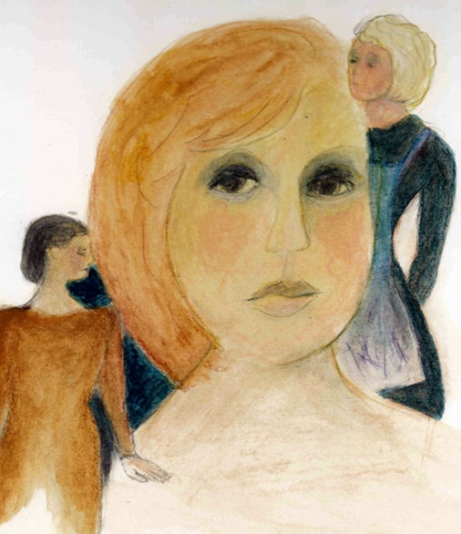
The search into my second image was focused upon a thematic apperception test, focusing on the idea for interpretation which when conducted, shows intentions to prevail a predominant image that encouraged a natural outlook of my character. I describe the image as a women looking into the mirror and in her reflection she sees herself and the different products of her life that she must be. Darkness looming in the background shows loss or perhaps desperation. Looking at her physical self, she sees a small desperation of her inner self-protruding onto her outer appearance. Although living a comfortable life married with children, she feels a sense of loss of her own self. Looking further within herself, she sees the domestic person who has become a part of what she is, as well as taking pride in her abilities to maintain a successful household. Looking more in depth she sees a professional and dainty woman; on the contrary knowing, that ‘self’, has been put into the shadows and only reappears sporadically and when needed. Combined in her reflection she sees what makes up a whole of who she is today. Pride is an intimate need for her abilities to do ‘it all’, occasionally lack of power leaves her feeling helpless and achievement is what she has accomplished. Ultimately, I found that what I was describing was how I see myself.

My infamous flag that was created with false pretentions of a person who I thought I represented. Only to be mistaken and developed into a self-discovery that I never seen coming! Upon constructing my flag, I was merely incorporating objects that relate to my Self. Looking further in detail, I begin to notice that it was more than just ‘raw’ representation of myself. Personally, looking at each picture individually and the placement, size, and color I see now, that all the while it was my unconscious constructing it for me all the while. Love, success, female power, goals, overwhelmed, happy, strong, marriage, psychology, female, mother, student, fire and lightening are the basic images that were incorporated into my flag (script). If I were to strip them away, I ask myself “what would be left”? With the collection of images, I began to uncover my developing theory into personality.

Psychosocial Theory
My developments of psychosocial theory are loosely based on the ideas of Erik Erikson’s psychosocial development. Each stage in life allows a person to experience personal growth, challenges, and experiences that reflect all throughout one person’s life span. Although Erikson believes in eight stages, I on the other hand feel that the development of life can be imperatively based on five stages, infant (birth – 2 years), child (3 – 5 years), adolescent (6 – 12 years), teenager (13 – 24), and lastly, adult (25 – death).
Stages of psychosocial theory development endure merging; for that, there is a commonality of growth (physical, emotional) in each particular stage, more time of each is imperative in the development of life’s progress. Relationships we build throughout stages of life are a direct influence in who we are, who we once were, and ultimately who we will one day become. People we interact with daily can have an effect on a person’s character, behavior and personal development depending on whether what it is we gather is a negative or a positive influence. Unfortunately negative influences stem more often than not from a goodhearted acquaintance, friend, relative, or family member that which result from assistance, advice, or information. Filling our lives with positive influences has an improved effect on a person’s ultimate destiny. Surrounding ourselves with people who have positive influences or rather, to be a positive influence on others shows the optimistic, disciplined, confident, supportive, cheerful, honest, and loving inclination benefits everyone involved. People require a certain amount of approval; whether consciously or unconsciously, will in turn affect how much they influence oneself. However, one must consider if their influences will make us fall into conformity by changing our ‘Self’ to merely impress or be like our influencers.
To understand conformity you must first comprehend why people conform. Alleviation of stress by matching our attitudes and behaviors with those around us can be beneficial. Conformity is not necessarily considered a bad schema; it can also have some positive attributes as well. Conformity allows for discussion and debate that which can be crucial in creating harmony amongst a group.

Self-Actualizing Theory
Humans have a unique desire in achieving our highest potential; focusing on personal experiences and subjective perception of the world, resulting in the ongoing process that we are constantly asking ourselves “What can I be?” and “What must I be?” Ultimately, placing those needs in what is known as a Hierarchy that includes the desires for self-fulfillment to the highest potential and capability a person can become. I can relate to these questions for I am constantly debating amongst myself of who I can and must be.

Cognitive Theory
How we choose to understand and interact within a world that is overflowing with people filled with personalities, stands as a thought process that is determined by our feelings and behaviors, and how we choose to react. Engrossed with the need for ‘wanting’ and ‘knowing’, we are in constant contemplation in figuring out how to process the world around us.
When considering individual thought processes, the interaction between the individual and the world, is the primary focus when considering the result of the process is objective. Thought processes are not simply available without a structured mental illustration. Schemas are just that, a conformity, pattern, or behavior a person will call to memory at that time when the behavior is in fact acted upon in a familiar fashion, ultimately creating our scripts. When a person is confronted with a new situation, the tendency is to relate the situation to a familiar schema and incorporate a required adjustment. My flag is a graphic example of the many scripts I play in order to conform to my world; a process of rebuilding, that can and may take the entirety of my life.

Summary
Today I am a collection of who I was and who it is I will become. Each moment passed is another experience that is taken as a journey throughout the course of life. To emphasize my philosophies in the structure of my ‘Self’, I consider the accrued characteristics of which have developed throughout the stages of my life into an accumulation of who I am today. Possibly the most beneficial characteristics I have developed may have come from the many stages of life, starting with the early stage of infancy; the acceptance for attachment, a trusting demeanor, and the willingness to look at life through innovated eyes. Furthermore, I am an incorporation of a carefree and eager child, a timid, but curious adolescent, as well as a headstrong responsible student. Determination as a result of conflict, and success as a result of failure; these are the experiences that have motivated my desires to reach past the stars and light the fire within, to not only achieve my own goals, but to help those around me achieve their own.
Regardless of an individual’s potential, failure is at times unavoidable and often a fallacious interpretation of oneself. The capability in recognizing our weaknesses perhaps result in becoming our greatest strengths. During a good portion of my childhood, I allowed myself to fall victim to my mother’s demons. As I succumbed to the image of having a mother who was addicted to methamphetamines, I immobilized my ‘Self’ from the discovery of my own identity. Just as a person is able to grow physically, I eventually allowed my ‘Self’ to grow emotionally as well as mentally. When the motivation inside of me was starting to appear, I realized that one person’s weakness is merely the foundation for one person’s strengths.
I was not valedictorian. I do not spend hours volunteering; I am not a perfect daughter, sister, friend, wife, or mother. Throughout life, I have used many mechanisms for denying, excusing, disguising and changing my behaviors in order to avoid anxiety and frustration. I have repressed memories from my childhood in order to redefine myself; however, I have learned that confronting memories is more beneficial in coping. I have used denial towards a person, memory or happening; in turn, learning that it only delays the inevitable. I have rationalized behaviors for others and myself in hopes to make true reasoning go unnoticed. I have often displaced feelings in order to avoid my own faults and frustrations towards something or someone as a substitute; additionally projecting unacceptable impulses towards others. Often people use the reaction formation mechanism in order to persuade those around us that we are feeling opposite of what we present. Correspondingly, to wear a mask so that others are unable to see our cries, our lies, our tears and sighs. Who I am? I fear that I am still not sure. I have yet to understand personality or the Self that constructs who I am. Maybe in the realizations of who I am not, I could eventually find … Discover… Understand…. Get to know…. The person I am, because after all, is that not what life is about?
Finally, if I were to guess who is it that incorporates this combination of personality inside of me? Humbly I answer, my ‘Self’. A ‘Self’ that has been through more than most at my age. A ‘Self’ that has pulled herself up from a place that many doubted she could. A ‘Self’ with an ability to turn the worst situation into the best, and a ‘Self’ that knows she would not be who she is without the mutual respect and valued relationships of everyone around her, and most importantly a ‘Self’ that acknowledges that she is the perfection of her imperfections.

