Statistical Study
Head Circumference vs. Height
Ashley Soechtig
Brian Merdes
Kirtus Thacker
Krysti Libby
Sheena Christison

Height vs. Head Circumference
A doctor recently stated that the size of a person’s head is a good indication that you will or will not be taller than the average child. So our thoughts were to put this to the test. If your head measures out larger than average, you will be tall, if your head measures smaller than average, you will be shorter than the average child. Doctors have a chart that measures if you are on track with the average child height and head circumference.

Hypothesis
Our hypothesis is that there is a direct correlation between a child’s height and head size, the taller the child, the larger the head circumference at birth. As the child’s height increases so does the head circumferences.

Data Collection
Source: Statistics Textbook Third edition By Michael Sullivan, III 4.1.23
(Sullivan III, 2008)
Equation Line for Model:
Y = 0.1827x + 12.493
X~Height | Y~Head Circumference
27.75 | 17.5
24.5 | 17.1
25.5 | 17.1
26 | 17.3
25 | 16.9
27.75 | 17.6
26.5 | 17.3
27 | 17.5
26.75 | 17.3
26.75 | 17.5
27.5 | 17.5

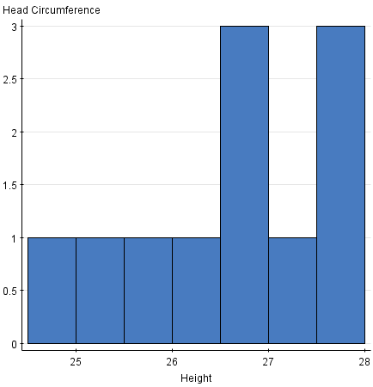
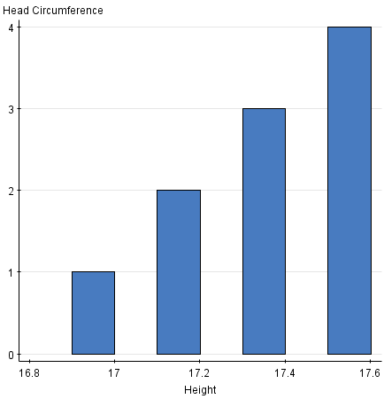

Height data (X): Shows that the average height for the sample collected is 26.455 inches, with no outliers and a standard deviation of 1.043.

Q3 = 27.5
Q1 = 25.5
IQR = 2.
Upper fence = 30.5
Lower fence = 22.5.
There are NO outliers
Mean = 26.455
Standard Deviation = 1.043

Head circumference data (Y): Shows that the average head circumference for the sample collected is 17.327 inches, with no outliers and a standard deviation of .209.
Q3 = 17.5
Q1 = 17.1
IQR = .4
Upper fence = 18.1
Lower fence = 16.5
There are NO outliers
Mean = 17.327
Standard Deviation = .209

Correlation Coefficient/Risidual
Test: We found that ‘r’ is greater than the critical value for correlation coefficient of .602 for a sample of eleven. r = .911 and r^2 = .83

Predicted Y | Residual
17.562925 | -0.062925
16.96915 | 0.13085
17.15185 | -0.05185
17.2432 | 0.0568
17.0605 | -0.1605
17.562925 | 0.037075
17.33455 | -0.03455
17.4259 | 0.0741
17.380225 | -0.080225
17.380225 | 0.119775
17.51725 | -0.01725

Raw Data

Chart II: Residual Line

Linear Model Assumption
There is a positive linear relationship between the height of the child and the circumference of the child’s head. The best fit line equation of this relationship is the circumference= 0.1827x + 12.493
Where Y is the head circumference in inches, and X is the height of the child in inches (see chart one). R= .911 which means this line is close to one, which makes it a best-fit line. When comparing the data in our final conclusion to our hypothesis our group found that are final conclusion supported our hypothesis. There is a direct correlation between a child’s height and head size, the taller the child the larger the head circumference. As the child’s height increase so does the head circumference. With testing our hypothesis we did find that head circumference and height do in fact correlate with one another.
Chart III – Best Fit Line

Prediction
We predict that using the regression line equation, a child that is 25.75 inches tall would have a head circumference of Y= 0.1827(25.75) + 12.493= 17.1975 inches. This result fits perfectly with our data. For example; from our data, we proved that: A person who is 25.5 tall has a head circumference of 17.1 inches. Furthermore, a child who is 26 inches tall has a head circumference of 17.3 inches.

Conclusion
As a group we collected our data from the text book. Our conclusion showed that our analysis was correct and did in fact make sense. Our only reservations towards are chosen sample, is that it would have been more beneficial to have a larger sample.

References
Sullivan III, M. (2008). Statistics:. In Informed Decisions Using Data (Third Edition ed.). Pearson.

